Hong Ngoc

**Wireframe/Mockup**  **Document Bus ticketing**

##### **Date: 05/03/2025**

##### **Version: 1.0**

##### **Author: Nguyen Pham Hong Ngoc**

### **1. Introduction**

* **Purpose:**This document provides wireframes/mockups for the Project: **Document Bus ticketing** to illustrate the intended user interface design. These wireframes/mockups are subject to review and approval before development begins.
* **Scope:**The wireframes/mockups cover the following screens:
  + Screen 1: Login
  + Screen 2: Login with Facebook
  + Screen 3: Login with Google
  + Screen 4: Create an account
  + Screen 5: Find password
  + Screen 6: Confirm OTP
  + Screen 7: Create a new password

### **2. Wireframes/Mockups**

### **2.1 Screen 1 Name: Login**

* **Description:**The purpose of the login screen is for users to log into the bus ticket search and booking system.
* **Wireframe/Mockup:**

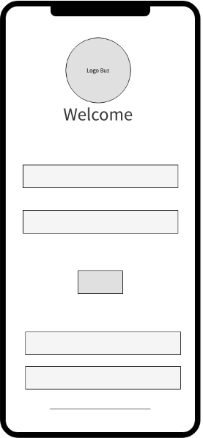

* **Annotations:**
  1. **Header:**The header includes the app logo in orange and the black text “Welcome” in the top center, large in size because this is the main page of the app to highlight the app.
  2. **Main Content Area:**The main content area is located in the center, displaying 2 login and password dialog boxes that allow users to enter their login name and password if they already have an account to log in to the app. Including 1 dialog box containing the login name and 1 dialog box containing the password. Below the 2 dialog boxes is the “Login” button that allows users to log in to the app by clicking on it.
  3. **Lower part:**Below are 2 dialog boxes "Login with Facebook" and "Login with Google" allowing users to choose to log in differently when they do not have a previous account.
  4. **Bottom of page:**At the bottom of the page is the line “Don’t have an account? Sign up”. Allows users to click to create an account if they don’t have one..

#### **2.2 Screen 2,3 Name: Login with Facebook, Google**

* **Description:**The purpose of both of these screens is for users to log in to the app without an account by logging in with a FaceBook account or a Google account.
* **Wireframe/Mockup:**

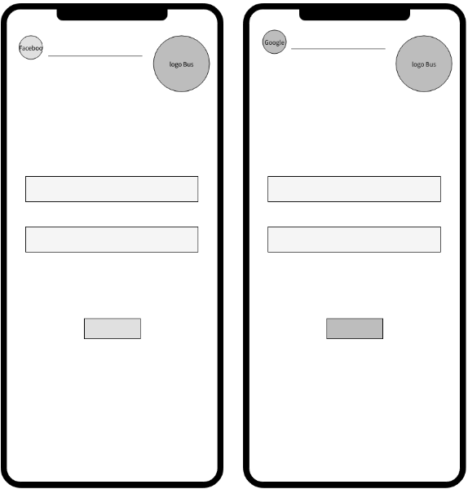

* **Annotations:**
  1. **Header:**

On the top left corner of the 2 screens is the Fb/Gg logo, along with the words Log in with Fb/Log in with Gg. The logo color is the same as the original logo, the words are black. On the top right corner is the logo of the orange color application, smaller in size than the logo on the login screen.

* 1. **Main Content Area:**

Both screens have 2 Email or phone number and password dialog boxes, allowing users to enter information to log in to the application. Below the 2 information entry dialog boxes is the authentication button, when the user has finished entering the login information, click here to log in to the application.

**2.3 Screen 4 Name: Create an account**

* **Description:**This screen describes the information entry fields that are intended to allow users to create new accounts when they do not have a login account.
* **Wireframe/Mockup:**

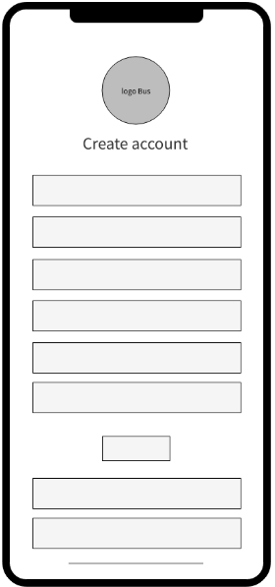

* **Annotations:**
  1. **Header:**Above in the middle is the app logo, below the logo is the text Title “Create new account”.
  2. **Main Content Area:**The screen has dialog boxes that allow users to enter personal information. Including the boxes: enter Full name, enter login name, enter phone number, enter Gmail, enter password and confirm password. To allow users to enter personal information into each box displayed on the screen. The rows of boxes are uniformly bordered with orange and white backgrounds like the main tone of the app. Below the dialog boxes there is a "Register" button, to allow users to click here to register after entering information. After completing the registration, return to the login screen.
  3. **Bottom of the screen:**

There are 2 dialog boxes similar to screen 1, allowing users to log in with Facebook/Google without registering an account.

And finally, there is the line "Already have an account? Login" to help users click to log in when they already have an account (for example: if you already have an account but accidentally click to create a new account, the function of this line is to return to the login screen).

**2.4 Screen 5,6 Name: Find password, Confirm OTP**

* **Description:**This screen is intended to allow users to easily retrieve their password when they forget it by entering their phone number/gmail, screen 6 to help users enter and confirm the OTP code to support the password recovery step.
* **Wireframe/Mockup:**

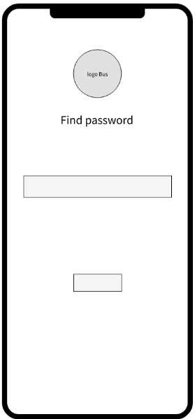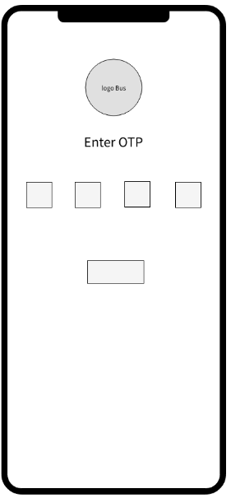

* **Annotations:**
  1. **Header:**The header has an orange logo of the app, located in the middle near the top edge of the screen. Below the logo is the line “Find Password” which clearly shows the user’s purpose.
  2. **Main Content Area:**There is a white background orange border dialog box: to allow users to enter phone number/gmail to proceed to find the password for the account. Below the information entry dialog box is the "Confirm" button: to allow users to use it to confirm after entering the information above. Finish entering information to find the password, move to another screen.

There is a line of text that says enter OTP code from phone number or gmail: to let users know the purpose of use. Below the line of text are 4 small squares, equivalent to a 4-digit OTP code for users to enter, confirming support for password recovery. And below the row of squares is the "Confirm" button: to allow users to click to confirm after entering the OTP code above. Finish entering OTP, move to another screen.

**2.5 Screen 7 Name: Create a new password**

* **Description:**This screen is intended to allow users to reset a new password for their account to log into the app.
* **Wireframe/Mockup:**

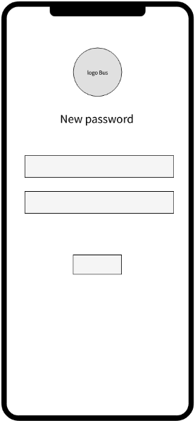

* **Annotations:**
  1. **Header:**The header is similar to the 4.5 screen, with an orange logo representing the app, located in the middle near the top edge of the screen. Below the logo is the line “Create new password” which clearly shows the user’s purpose.
  2. **Main Content Area:**There are 2 orange-bordered, white-background dialog boxes:
* Box 1: enter new password
* Box 2: confirm new password

→ both dialog boxes allow users to enter the password twice to create a new password

Below the 2 dialog boxes is the “Confirm” button, allowing users to click to perform the confirmation step. Finish the step of creating a new password to move to the login screen.

### **3. Notes**

* **Usability Considerations:**Add a back button
* **Feedback:**Design reviewed by tester on 5 March 2025, with suggestions to increase font size for readability

Le Vi

#### **Wireframe/Mockup Document Bus ticketing**

##### **Date: 05/03/2025**

##### **Version: 1.0**

##### **Author: Nguyen Le Thao Vi**

### **1. Introduction**

* **Purpose:**This document provides wireframes/mockups for the Bus ticketing to illustrate the intended user interface design. These wireframes/mockups are subject to review and approval before development begins.
* **Scope:**The wireframes/mockups cover the following screens:
  + Find a trip
  + Show a list of trips
  + Fill in seat information
  + Select a seat

### **2. Wireframes/Mockups**

#### **2.1 Screen 1 Name: Find a trip**

* **Description:**This screen allows users to search for rides. Users can search by specific time and location.
* **Wireframe/Mockup:**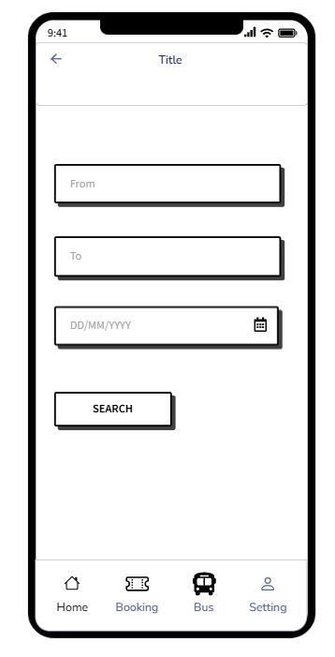
* **Annotations:**
  1. **Header:**The header includes the logo in the center and navigation on the left.
  2. **Main Content Area:**Displays three input fields including "From", "To", and "Date" (with a calendar icon to select a date), along with a "SEARCH" action button. The components are arranged vertically, creating a neat and easy-to-use look.
  3. **Footer:**The footer includes a “Home” button, a “Booking” button, a “Bus” button and a “Setting” button.

#### **2.2 Screen 2 Name: Show a list of trips**

* **Description:**This screen displays a list of available bus trips after the user performs a search. The user can choose the appropriate trip.
* **Wireframe/Mockup:**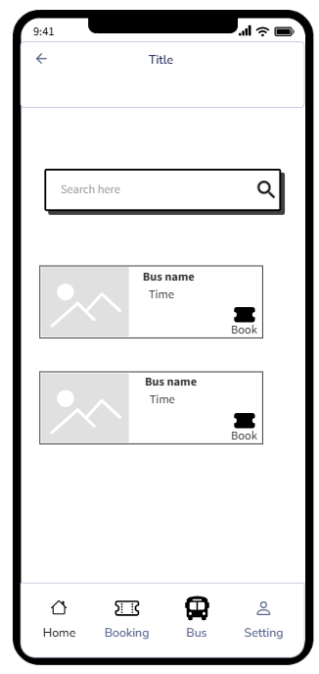
* **Annotations:**
  1. **Header:**The header includes the logo in the center and navigation on the left.
  2. **Main Content Area:**The top section has a search bar that allows users to filter further information. The main content area displays each bus with a picture, bus name, departure time, and a "Book" button for quick ticket booking.
  3. **Footer:**The footer includes a “Home” button, a “Booking” button, a “Bus” button and a “Setting” button.

#### **2.3 Screen 3 Name: Fill in seat information**

* **Description:**This screen allows users to enter personal information to book bus tickets.
* **Wireframe/Mockup:**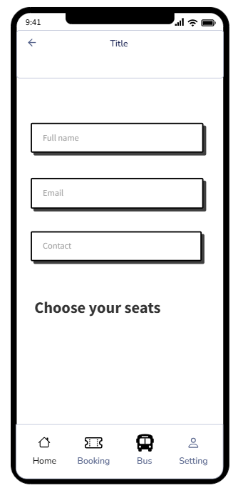
* **Annotations:**
  1. **Header:**The header includes the logo in the center and navigation on the left.
  2. **Main Content Area:**The main content area displayed includes three input fields: "First and Last Name", "Email", and "Contact". Below is a "Select Seat" guide to help users choose the right seat. The navigation bar at the bottom makes it easy to switch between other functions of the app.
  3. **Footer:**The footer includes a “Home” button, a “Booking” button, a “Bus” button and a “Setting” button.

#### **2.4 Screen 4 Name: Select a seat**

* **Description:**This screen allows the user to select a seat on the bus. The squares represent the seats, which the user can choose from.
* **Wireframe/Mockup:**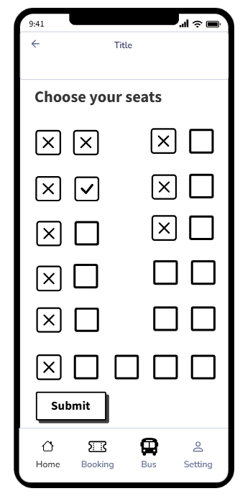
* **Annotations:**
  1. **Header:**The header includes the logo in the center and navigation on the left.
  2. **Main Content Area:**The main content area is displayed Squares represent seats, where: An "X" indicates a reserved seat. An empty square indicates an available seat. The selected seat is displayed with a check mark ("✓"). The user can select the desired seat and press the "Submit" button to confirm the selection. The navigation bar at the bottom makes it easy for the user to move between other functions in the application.
  3. **Footer:**The footer includes a “Home” button, a “Booking” button, a “Bus” button and a “Setting” button.

### **3. Notes**

* **Usability Considerations:**Ensure seat selection is user-friendly, with clear differentiation between available, selected, and booked seats.
* **Feedback:**Design reviewed by tester on 6 March 2025, with suggestions to increase font size for readability

Nhuan Tien

#### **Wireframe/Mockup Document Bus ticketing**

##### **Date: 05/03/2025**

##### **Version: 1.0**

##### **Author: Nguyen Nhuan Tien**

### **1. Introduction**

* **Purpose:**This document provides wireframes/mockups for the Bus ticketing to illustrate the intended user interface design. These wireframes/mockups are subject to review and approval before development begins.
* **Scope:**The wireframes/mockups cover the following screens:
  + Booking history
  + Cancel booking
  + Payment information
  + Payment method
  + Payment succesful and ticket information

### **2. Wireframes/Mockups**

#### **2.1 Screen 1 Name: Booking history**

* **Description:**This screen allows users to view the history of booked bus tickets. Users can proceed with payment or cancel bookings for bus trips that have not yet taken place.
* **Wireframe/Mockup:**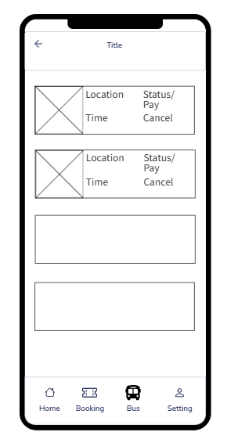
* **Annotations:**
  1. **Header:**The header includes the logo in the center and navigation on the left.
  2. **Main Content Area:**The main content area displays a list of tickets. Each ticket is presented with an image, location, time, and status. If the ticket is unpaid, the status is changed to a “Pay” button and a “Cancel” button is added.
  3. **Footer:**The footer includes a “Home” button, a “Booking” button, a “Bus” button and a “Setting” button.

#### **2.2 Screen 2 Name: Cancel booking**

* **Description:**This screen asks the user to confirm the cancellation action. The booking history screen is dimmed, a pop-up asking for confirmation of cancellation will appear.
* **Wireframe/Mockup:**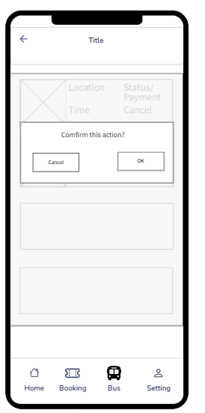
* **Annotations:**
  1. **Header:**The header includes the logo in the center and navigation on the left.
  2. **Main Content Area:**The main content area displays a request to confirm the cancellation. If the user clicks the "OK" button, the booking will be canceled, otherwise the booking will be kept.
  3. **Footer:**The footer includes a “Home” button, a “Booking” button, a “Bus” button and a “Setting” button.

#### **2.3 Screen 3 Name: Payment**

* **Description:**This screen appears when the Pay button is clicked. It allows the user to view the total paid and confirm the payment.
* **Wireframe/Mockup:  
  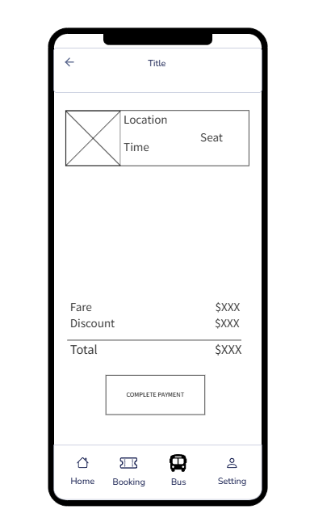**
* **Annotations:**
  1. **Header:**The header includes the logo in the center and navigation on the left.
  2. **Main Content Area:**The main content area displays ticket information, fare, discount, total and payment button. Clicking the payment button will take you to the payment method screen.
  3. **Footer:**The footer includes a “Home” button, a “Booking” button, a “Bus” button and a “Setting” button.

#### **2.4 Screen 4 Name: Payment methods**

* **Description:**This screen appears when the Payment button is clicked. It allows the user to select the appropriate payment method.
* **Wireframe/Mockup:  
  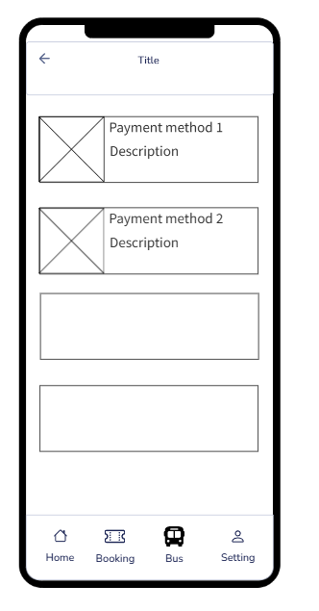**
* **Annotations:**
  1. **Header:**The header includes the logo in the center and navigation on the left.
  2. **Main Content Area:**The main content area displays a list of payment methods. Each method is presented with an image, method name, and a short description.
  3. **Footer:**The footer includes a “Home” button, a “Booking” button, a “Bus” button and a “Setting” button.

#### **2.5 Screen 5 Name: Payment successful and ticket**

* **Description:**This screen appears when payment is successful. It shows payment information and ticket.
* **Wireframe/Mockup:  
  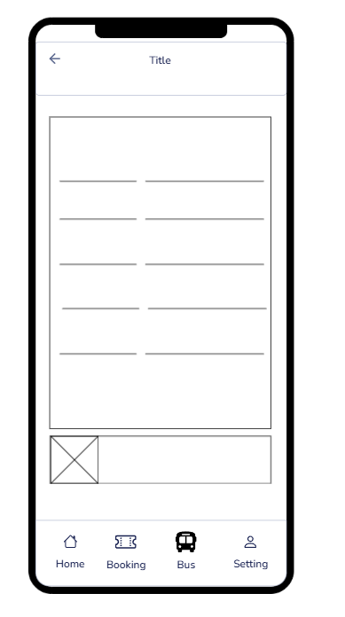**
* **Annotations:**
  1. **Header:**The header includes the logo in the center and navigation on the left.
  2. **Main Content Area:**The main content area displays ticket information and payment information including: date, time, recipient, payment method and ticket price.
  3. **Footer:**The footer includes a “Home” button, a “Booking” button, a “Bus” button and a “Setting” button.

### **3. Notes**

* **Usability Considerations:**Add a cash payment method.
* **Feedback:**Design reviewed by tester on 6 March 2025, with suggestions to increase font size for readability